**Snake Game Proposal**

**Introduction:**

For my first project I want to build a simple yet smooth animated snake game. I will be using HTML, CSS and JavaScript to code this. The game will consist of a game window which by default will have a loaded snake in the center. On any direction key press the snake will begin to move and the game will start. Food pieces will spawn randomly on screen which the snake must eat. As you eat more food the length of the snake will increase. If you hit either the window wall or yourself you will lose. I could also incorporate snake speed increase as you progress through the game.

**User story:**

* As a user I should be able to start a game on move
* I should be able to see a snake on screen move
* I should be able to change direction on key down
* A food should spawn at a random location on screen
* Snake length should increase upon food eat
* If snake hits window wall, should end game & display game over
* If snake hits itself, should end game & display game over
* I should be able to see my current and high score

**Wireframe examples:**

Desktop layout

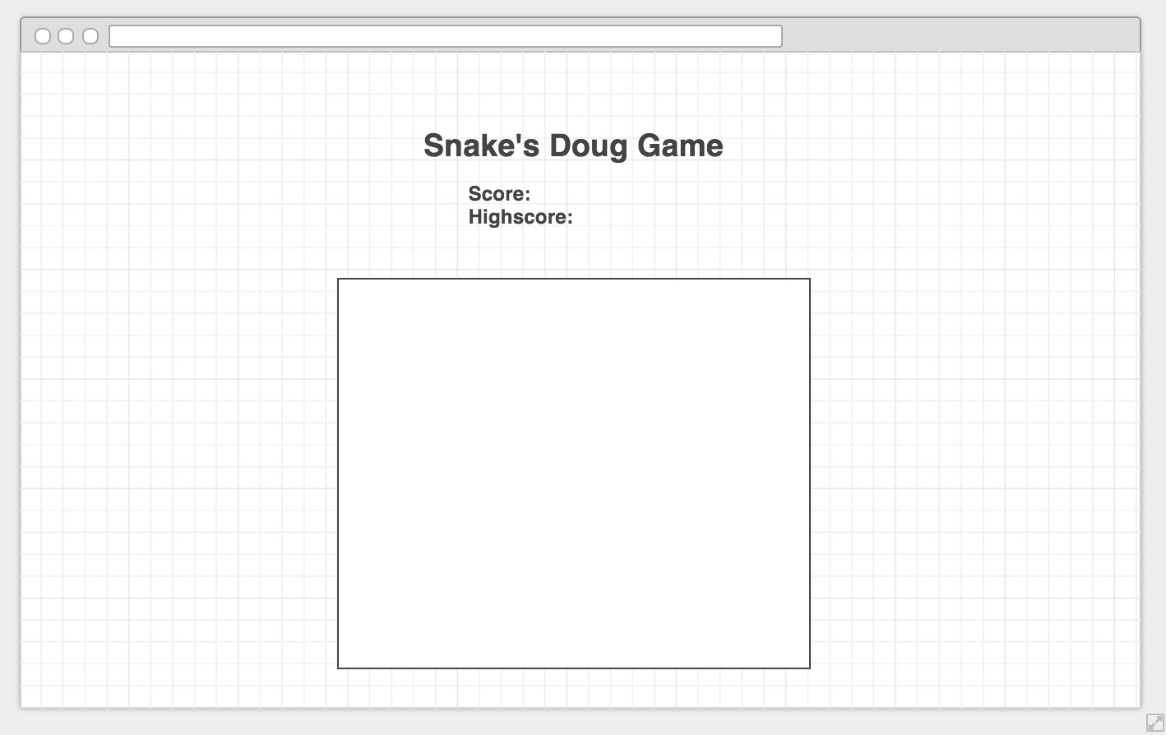

Tablet/mobile layout

